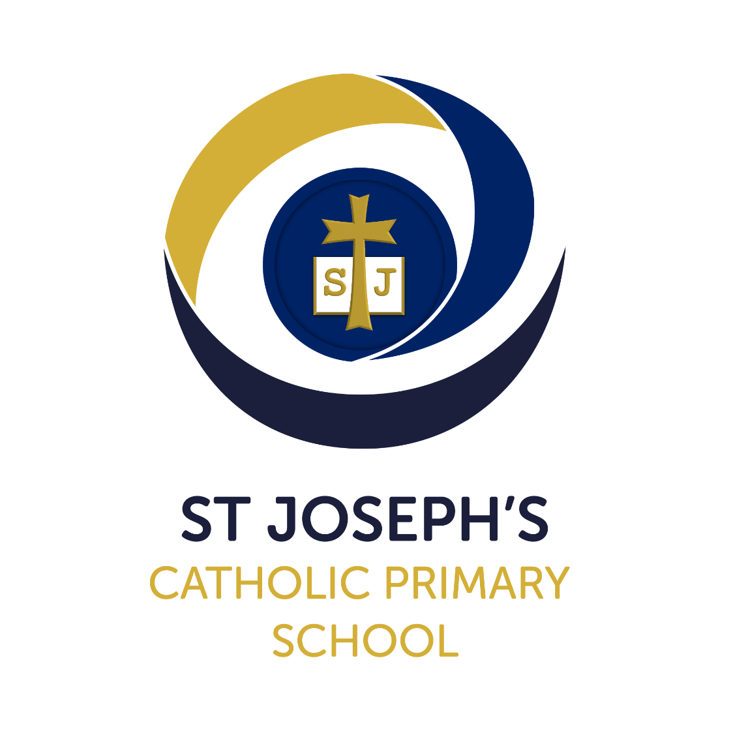
PE Policy

Version: | 1
Date created/updated: | 05.09.2023
Ratified by: | Local Governing Body
Date ratified: | 10.10.2023
Date issued: | October 2023
Policy Review Date: | September 2024
Post Holder Responsible for Review: | Principal

Commitment to Equality:

We are committed to providing a positive working environment which is free from prejudice and unlawful discrimination and any form of harassment, bullying or victimisation. We have developed. a number of key policies to ensure that the principles of Catholic Social Teaching in relation to human dignity and dignity in work become embedded into every aspect of school life and these. policies are reviewed regularly in this regard.

This PE Policy has been approved and adopted by St Joseph’s Catholic Primary School on 10.10.2023 and will be reviewed in September 2024

Signed by the Chair of the Local Governing Body for St Joseph’s Catholic Primary School:

John Coyne

Signed by the Principal for St Joseph’s Catholic Primary School:

Anthony Wilkes
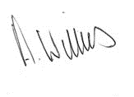

School Mission Statement
In following the Gospel values of Jesus, we are called to love, to learn and to respect one another.
Introduction
- At St Joseph’s Catholic Primary School, we are committed to providing all children with learning opportunities to engage in Physical Education. This policy reflects St. Joseph’s values and philosophy in relation to the teaching and learning of Physical Education. It sets out a framework within which teaching staff can work, and gives guidance on planning, teaching and assessment.
Policy Aims (Intent)
- To develop skilful use of the body, the ability to remember, repeat and refine actions and to perform them with increasing control, co-ordination and fluency.
- To develop an increasing ability to select, link and apply skills, tactics and compositional ideas.
- To develop an understanding of the effects of exercise on the body, and on appreciation of the value of safe exercising as part of living a healthy lifestyle.
- To develop the ability to work as a team player, taking the lead and learning to work collaboratively with others.
- To promote an understanding of safe practice, and develop a sense of responsibility towards their own and others’ safety and well-being.
Curriculum and Planning Organisation (Implementation)
- Each class is timetabled for two lessons of PE per week.
- The hall, playground and playing fields are used to facilitate PE activities.
- The school currently employs a ‘Sport Educator’ from RB Gym and Sport to teach two hours of curriculum PE a week across Key Stage 1 and 2.
- Swimming lessons are provided for pupils in Year 3 and Year 4 led by a qualified swimming teacher at the Crystal Leisure Centre.
- Sport coaches from other local clubs provide additional opportunities to extend and enrich the PE curriculum (Out of School Hours Learning)
- A variety of extra-curricular activities are provided for pupils in Key Stage 1 and 2 before and after school as well as during lunch break periods.
- Through the School Games programme, children are given the opportunity to participate in sport throughout the academic year.

Early Years Foundation Stage
The EYFS framework is structured very differently to the national curriculum as it is organised across seven areas of learning rather than subject areas. The most relevant statements for PE are taken from the EYFS Statutory Framework are covered within the following areas of learning:
- Personal, Social and Emotional Development
- Physical Development
- Expressive Arts and Design
The children have access a range of daily activities to develop both their fine and gross motor skills and have unlimited access to a dedicated outside area.
Key Stage 1 and 2
- The school follows the ‘Complete PE’ programme of work across EYFS, Key Stage 1 and 2 which ensures that there is a progression of skills across the phases
- The school follows schemes of work provided by the Sport Educators (RB Gym and Sport) in accordance with National Curriculum guidelines.
- A variety of other resources are used to support the teaching of lessons i.e. Cybercoach, TOPs cards, PESSCL cards etc.
- Lessons are blocked into units of work to promote greater depth and understanding, developing skills, contextual application of these skills and the ability to perform reflectively.
- Swimming lessons take place for children in Year 4 during the Spring term. A top-up swimming programme is planned for pupils in Year 6 (Summer term 2) who have not achieved the swimming and water safety expectations.
Contribution of PE to teaching in other curriculum areas
English
Links between PE and English include: writing sequences, following/giving instructions, oral/peer assessments, speaking and listening, and movement within drama.
Maths
A Sport Educator from RB Gym and Sport delivers the ‘Active Maths’ programme to groups of children across the school on Tuesday mornings every week. This programme provides opportunities for children to develop core maths skills through practical activities. Links between PE and Maths include: measurement, shape and space, sequences, number, angles, position and movement, rotation and time.
ICT
Links between PE and ICT include: children capturing and recording performances (cameras/videos) for evaluation and the development of skills. Videos/images of professional/skilled athletes may also be used to help develop good technique.
PSHE
Links between PE and PSHE include: living a healthy lifestyle, co-operating/collaborating with others as part of a team, understanding fairness and equity of play.
SMVSC
Links between PE and SMVSC include: opportunities that support the social development of the children i.e. organisation of children into teams to work co-operatively and collaboratively with each other, to understand that every person, made in the image and likeness of God, has special talents and abilities and to develop to the person God wants them to be.
Inclusion
- Class teachers will ensure that spare PE kit is available for any occasional circumstances where a child does not have their own in school.
- Children will not be excluded from PE unless advised by a medical professional – written evidence of this is required by parents.
- Lessons will provide good quality experiences that are appropriately challenging for all children.
- Children will participate in different activities, but will all be given the same opportunity to achieve the aims through an appropriate range of activities.
- For children with limited gross motor skills, the integrity of activities will be maintained and expectations will take into account the needs of every child.
- For the purposes of competition, all children will be given the opportunity to experience this within lessons (intra-school competition).
Assessment and Recording (Impact)
- The National Curriculum (2014) Aims and Programmes of Study will form the basis of ongoing assessment of the children’s development in PE.
- Assessment will take the form of observations of children’s performances, discussions with children and peer and self-evaluation.
- Photographic evidence may also be used to evaluate the children’s work and evaluate their performance.
- Physical Development in the EYFS will be assessed as part of the children’s ongoing learning journeys.
- Class teachers will make a judgement based on ongoing ‘assessment for learning’ following units of work on a termly basis. This RAG rated method highlights which children are below, at or working above the expected standard.
- PE is included as part of the annual report to parents.
- The use of the PE and Sport Premium Funding is published on the school website on an annual basis (by 31st July).

Health and Safety
All staff have due regard to the current Association for Physical Education (AfPE) guidance when preparing and delivering PE lessons. The school is also a member of the AfPE and teachers are able to access the online resource to support with any health and safety matters associated with PE and Sport.
- Children are taught how to improve their own abilities to assess risks
- First aid equipment is available and designated staff (teaching assistants) are qualified to support in the event of an accident. Sport Educators (RB Gym and Sport) are also first aid trained.
- Inhalers for children with asthma are also available and are readily accessible if required.
- Regular checks are made on all equipment and staff must inform the PE coordinator if there are any concerns immediately. All large items are inspected on an annual basis.
- Children are taught how to move and use the apparatus safely under the supervision of an adult at all times.
- Children are made aware of safe practice and understand the need for safety when participating in any activity.
- Children are taught to understand the safety risks involved in wearing inappropriate clothing, footwear or jewellery.
- Teachers must ensure that no jewellery is worn during lessons and that long hair is tied back. If earrings cannot be taken out the activity must be adapted so that the child is still able to participate i.e coach or umpire an activity.
- Children must wear suitable footwear when travelling to and from the hall.
- Staff should dress appropriately to deliver PE lessons but must revert back to professional attire once the activity is complete.
Resources
- There is a variety of equipment to enable the children to achieve objectives, which are best suited for their age and stage.
- Gym tables and mats are stored in the school hall.
- All other equipment is stored in the blue container in the Key Stage 2 playground.
- Teachers must check that all equipment is safe and suitable for the activity being taught.
- Children must not collect or replace equipment unsupervised at any time.

Continued Professional Development
Training needs are identified as part of the performance management process and through discussion with the PE subject coordinator. Training opportunities relevant to the whole school are circulated to teachers through staff meetings and/or on display on the school noticeboard.
Sport Educators (RB Gym & Sport) are employed to work at the school to support teachers to develop staff confidence, knowledge and understanding in the planning and delivery of high-quality PE lessons. These opportunities will be made available to colleagues on a rolling programme throughout the year.
Monitoring and Review
- The subject coordinator will oversee the continuity and progression within annual and medium-term plans, and monitor the quality of teaching and learning through lesson visits and discussions with Sport Educators and the Director of RB Gym and Sport.
- The subject coordinator will support school staff, share expertise and arrange opportunities for continued professional development.

